Project Design Phase-II
Data Flow Diagram & User Stories

Date | 05 October 2026
Team ID | SWTID-2026-9175
Project Name | Auto Ticket Classification using Flow Designer
Maximum Marks | 4 Marks

Data Flow Diagrams:
A Data Flow Diagram (DFD) is a traditional visual representation of the information flows within a system. A neat and clear DFD can depict the right amount of the system requirement graphically. It shows how data enters and leaves the system, what changes the information, and where data is stored.

Data Flow Diagram – Auto Ticket Classification using Flow Designer
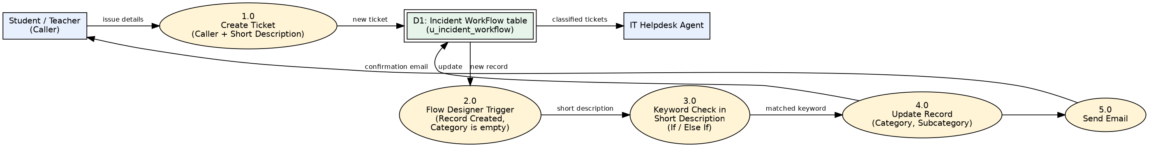

User Stories
Use the below template to list all the user stories for the product.
User Type | Functional Requirement (Epic) | User Story Number | User Story / Task | Acceptance criteria | Priority | Release
Student / Teacher | Ticket Creation | USN-1 | As a student / teacher, I can create an IT support ticket by entering my name (Caller) and a short description of the issue. | Ticket is saved with an auto-generated number | High | Sprint-1
 |  | USN-2 | As a student / teacher, I do not need to select Category or Subcategory manually. | Category and Subcategory are filled automatically after saving | High | Sprint-1
 | Email Notification | USN-3 | As a student / teacher, I receive an email confirming that my request has been submitted. | Email 'Your Request for the issue has been submitted' appears for my email address | High | Sprint-2
IT Helpdesk Agent | Auto Classification | USN-4 | As an IT agent, I want Wi-Fi / Network tickets classified as Network > Wi-Fi automatically. | Short description with Wi-Fi or Network sets Category = Network and Subcategory = Wi-Fi | High | Sprint-1
 |  | USN-5 | As an IT agent, I want Projector, Password and Slow Computer tickets classified automatically. | Hardware > Projector, Access > Forgot Password, Performance > Slow Computer are set from keywords | High | Sprint-1
 | Ticket Management | USN-6 | As an IT agent, I can view classified tickets and update State, Assigned group and Assigned to. | Tickets listed with correct category; State and assignment fields editable | Medium | Sprint-2
Administrator | Configuration | USN-7 | As an administrator, I can set up Category and Subcategory choices with dependency. | Subcategory list changes according to selected Category | Medium | Sprint-1
 |  | USN-8 | As an administrator, I can edit the flow to add new keywords in future. | New Else If branch can be added and the flow reactivated | Medium | Sprint-2
 | Deployment | USN-9 | As an administrator, I can export the project as an update set XML to share it. | Update set marked Complete and exported to XML | Low | Sprint-2

